Volunteer Registration Guide- Returning User
Navigate in your browser to https://leagues.bluesombrero.com/Default.aspx?tabid=2024502.
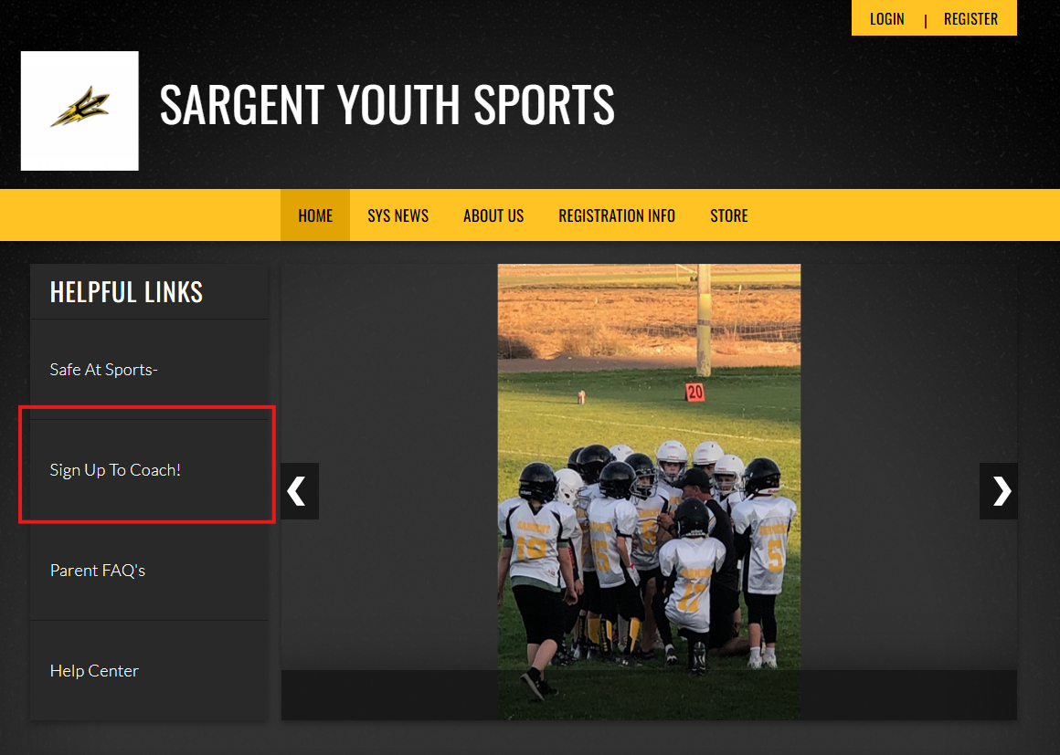
- Click “Sign Up To Coach!” under Helpful Links on the left-hand side of the main page of the SYS website.

- Select the Team you’re interested in coaching by clicking “+Sign Up”.
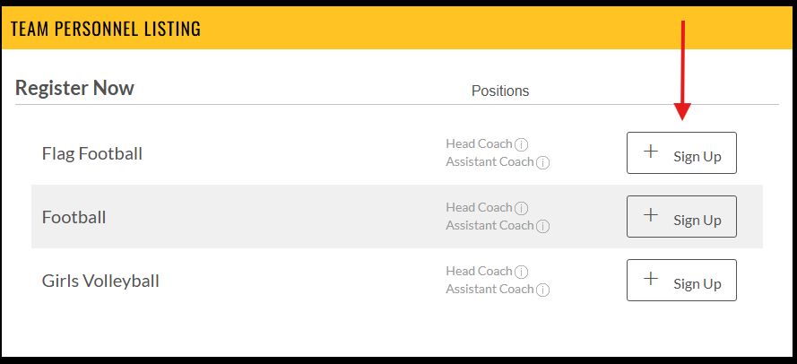

- You will be asked to create a SportsConnect account by entering your email, creating a password and confirming that password.
  - You will need to verify your new account through your email before you can finish in SportsConnect.
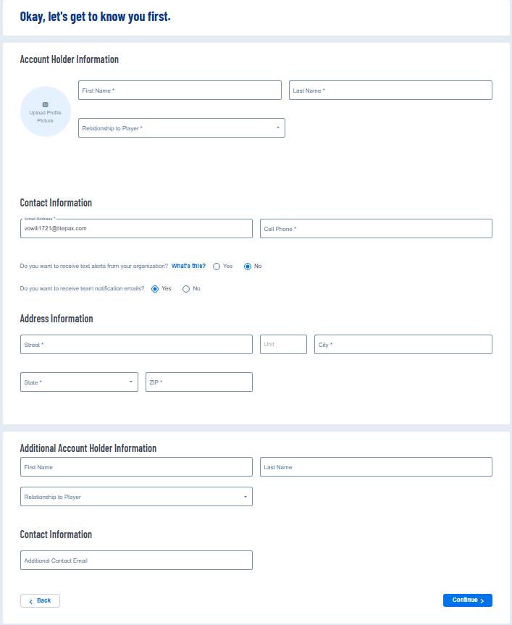
- Fill out the “Account Holder Information”, “Contact Information”, “Address Information”, and “Additional Account Holder Information” sections of the form and click continue.

- Select which opportunity you’re interested in coaching.
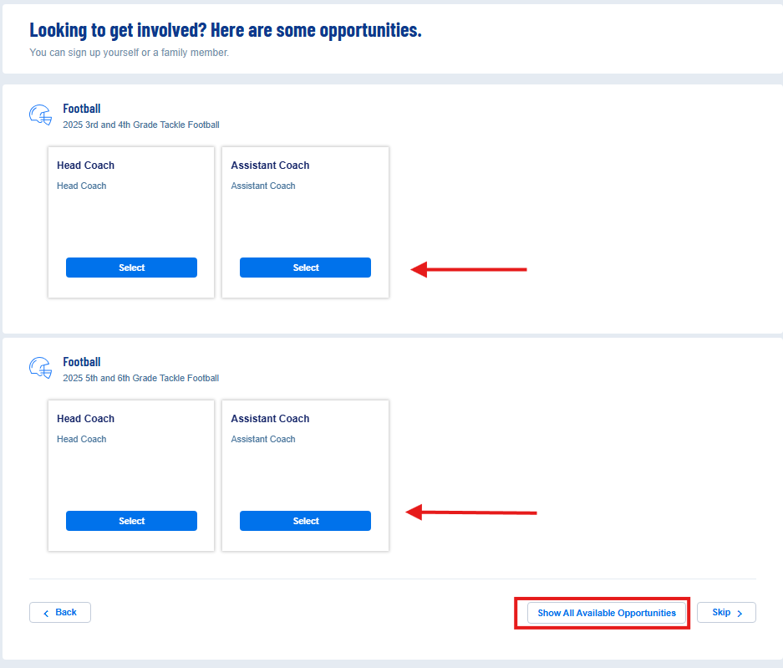
  - If you don’t see your sport here, click “Show All Available Opportunities” at the bottom to see all available coaching opportunities.

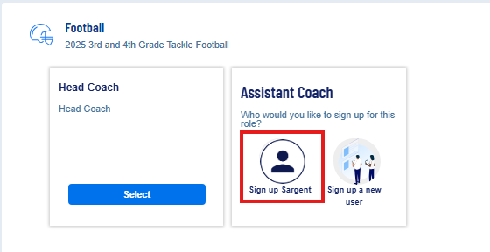
- Once you’ve selected the position you’re interested in, the tile will flip over showing you two options. Select “Sign up [your name]” and click continue in the bottom right-hand corner of your screen.

- Review your contact information. Proof of Identification is not required at this step; however, it will be required in order to run your background check.
  - If you do not have a completed background check from an outside entity or mandatory reporter training certificate to upload, you can skip the file upload.
  - If you have completed these steps, you can upload these files in this step.

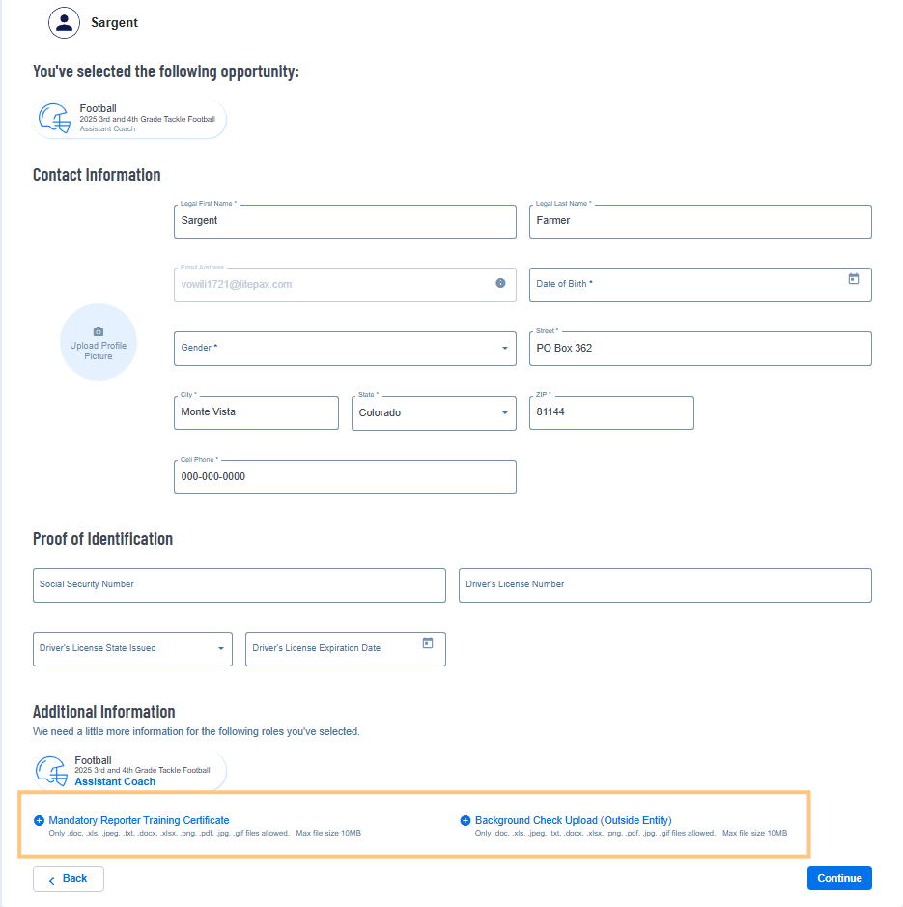
- Once you’ve clicked Continue, your submission is sent to SYS and Background Check instructions will be sent to you

